**Crook County Natural Resource District (CCNRD)**

**October 7th Regular Board Meeting Agenda**

**12:00 pm Sundance USDA Service Center**

**CALL MEETING TO ORDER**

**ATTENDANCE**

**Board**: Wayne Garman, Lily Altaffer, Wanda Burget, Kim Fundaun, Casey Devish.

**Employees**: Sarah Anderson, Jessica Halverson, Justice Miller

**Guests:** Carmen McIntyre-WACD (online)

**MONTHLY UPDATES**

1. Guest Updates
2. Updates by Jessica
   1. 319 BMP Applications for Payment *Signatures Needed (6)*
3. Updates by Justice
4. Updates by Sarah
   1. F-32 Dept. of Audit Forms Submitted
   2. NACD budget closeout
   3. WDEQ 319 budget/projections
   4. WDEQ proposal w/ JM
   5. Cedar Creek—contractors/BIL funding?
   6. Long-Range Plan Survey
5. Local Updates
6. Financials
7. Compensate SB & JM for using personal hotspot in office
8. Financial Voucher *Signatures Needed (3)*
9. Checks *Signatures Needed (2)*
10. Reconciliation Reports *Signatures Needed (3)*
11. Minutes
    1. Approve August 5th Minutes *Signatures Needed*

**OLD BUSINESS**

1. Ashley Coenen (contracting accounting)
2. Registration for Convention

* Full Convention Registration $275.00: Includes participation to all events and meals during the full 3 days of the Convention
* Day 1 of Convention - Nov. 19th $100.00: *Only* Includes participation in all events and meals during the first day of Convention
* Day 2 of Convention - Nov. 20th $175.00: *Only* Includes participation in all events, meals, and the Banquet & Auction during the second day of Convention
* Day 3 of Convention - Nov. 21st $40.00: *Only* Includes participation for Breakfast with Congresswoman Hageman and any other business during the final day of Convention
* Awards Luncheon - Nov. 20th $45.00: *Only* Includes attending the Awards Luncheon - showcasing winners of our many yearly contests and recipients of the Annual Awards
* Banquet & Auction - Nov. 20th $65.00: *Only* Includes attending the Banquet and Auction night, taking place the second day of Convention. Each induvial (including spouses of all attendees) must have their own ticket.

**NEW BUSINESS**

1. Alter WA work week to reflect calendar week
2. Computer/server/network/printer/phone/office space
3. New phone lines (direct lines)

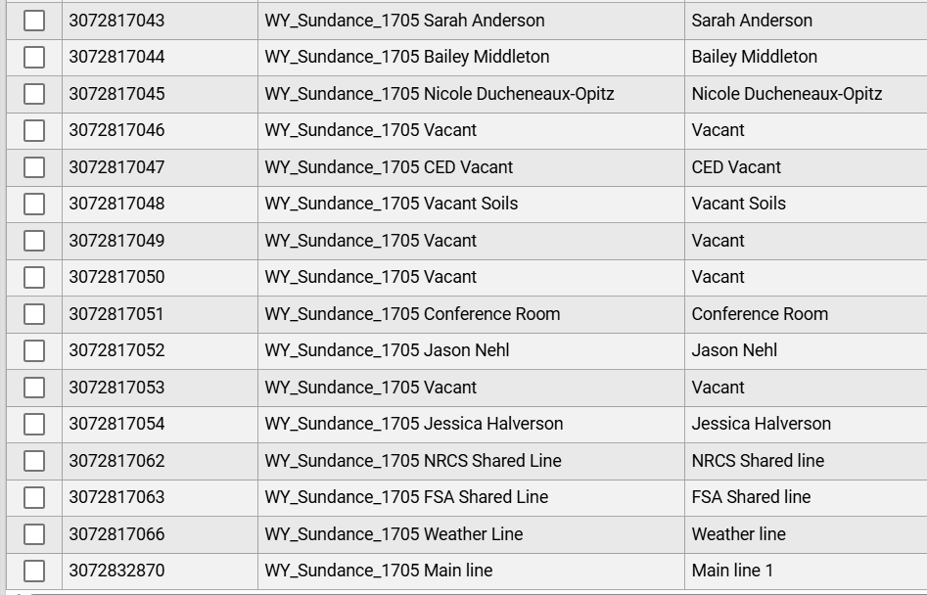

**OTHER BUSINESS**

1. Board Mileage

**SCHEDULE**

1. **County Commissioner’s Meeting,** *October 8th, 1:00 pm*
2. **Next Board Meeting,** *November 4th, 12:00 pm*
3. **Convention,** *November 19th – 21st*

**TIME OFF REQUESTS**

1. Justice Miller: November 6-7 to attend State Volleyball
2. Sarah Anderson: Early request for December 22-January 1 (mixed with teleworking)